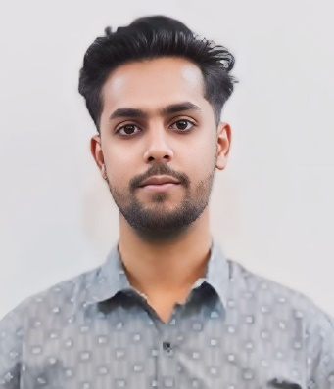 **SHAH MOHD IJHAR**

**Web Developer**

**Email:** *izharshah9305@gmail.com* **Ph:** +91 930-591-8540 **Add:** Sion, Dharavi, Mumbai-17

**CAREER OBJECTIVE**

* To pursue a better career in an esteemed Organisation where I can utilize and enhance my knowledge and skills for the development of both the Organisation and myself.

# QUALIFICATION

* Graduate in BSc(IT) from Rizvi College of Arts, Science & Com. Bandra(W)-(2022-2025).
* Passed out HSC from Rizvi College of Arts, Science & Com. Bandra(west) with 75.33% (2021-22)
* Passed out SSC from Dharavi T.C. English Secondary School with 77% (2019-20)

**TECHNICAL SKILLS**

* **HTML/CSS/JavaScript**
* **C/C++**
* **Java**

**STRENGHTS**

* Good Communication skill
* Time Management
* Team work & Hard working
* Goal Oriented

# HOBBIES & INTEREST

* Reading books
* Learning new things and Ideas
* Reading and Writing quotes

# PERSONAL INFORMATION

* Father name: Ansar Ahmad Shah
* Date of birth: 18/05/2003
* Gender: Male
* Marital status: unmarried
* Language known: English, Hindi, Urdu.

**WORK EXPERIENCE**

* Fresher

**DECLARATION**

* **I hereby declare that all the above mentioned information is true to the best of my knowledge and belief**.